Practical - 6
Practical Title: Rendering External JSON Data using Fetch API, Search and Filter

Problem Definition : Display event lists, student profiles, notices, or FAQs from external JSON files using Fetch API. Implement dynamic rendering, search, filter, sorting, and pagination.

Theory
1.How is JSON fetched, parsed, and rendered?
JSON data is fetched using fetch(), converted into JavaScript objects using .json(), and then displayed on the webpage using JavaScript.

2. Which array methods are used for search, filter, sort, and pagination?
Methods like filter(), sort(), and slice() are used for searching, filtering, sorting, and displaying data page by page.

3. How are loading and error states handled?
A loading message is shown while the data is being fetched, and an error message is displayed if the data cannot be loaded.

4. How is modularity maintained in JavaScript files?
Modularity is maintained by keeping different functions in separate JavaScript files and using them only where required.

Evidence of Work (Screenshots):
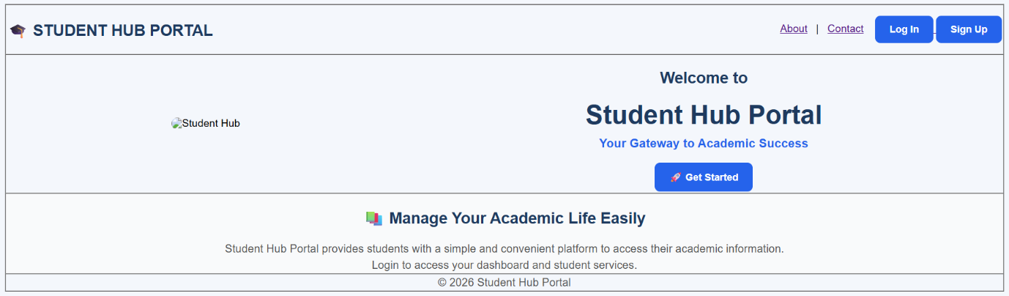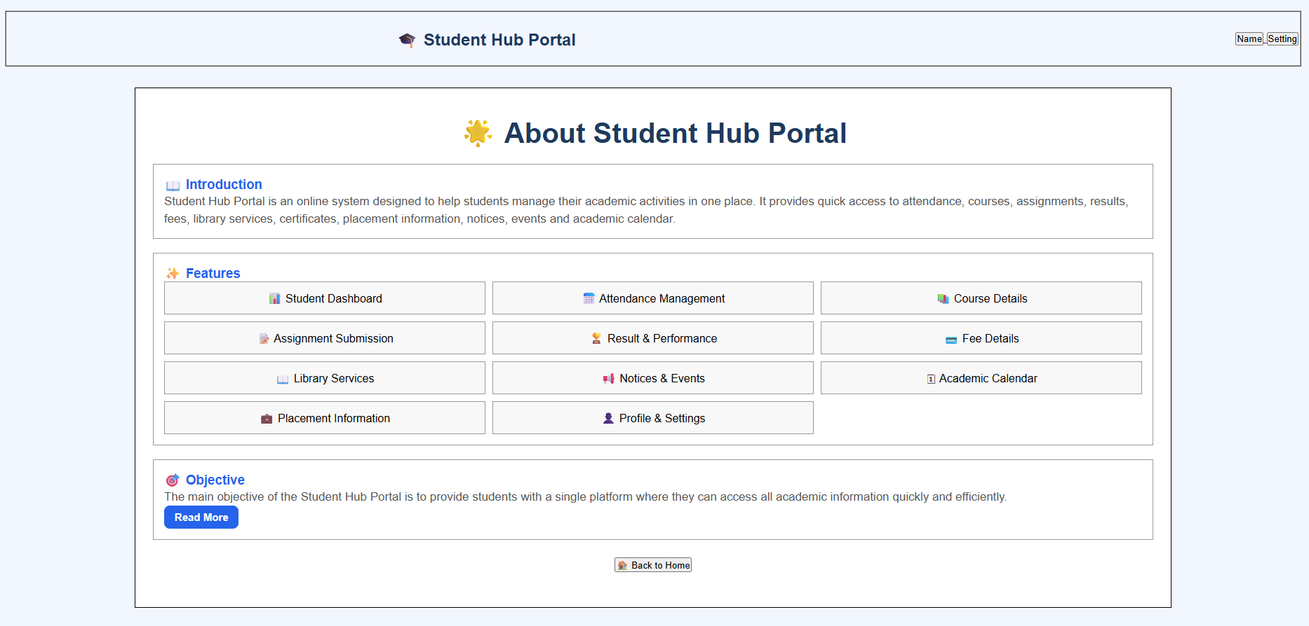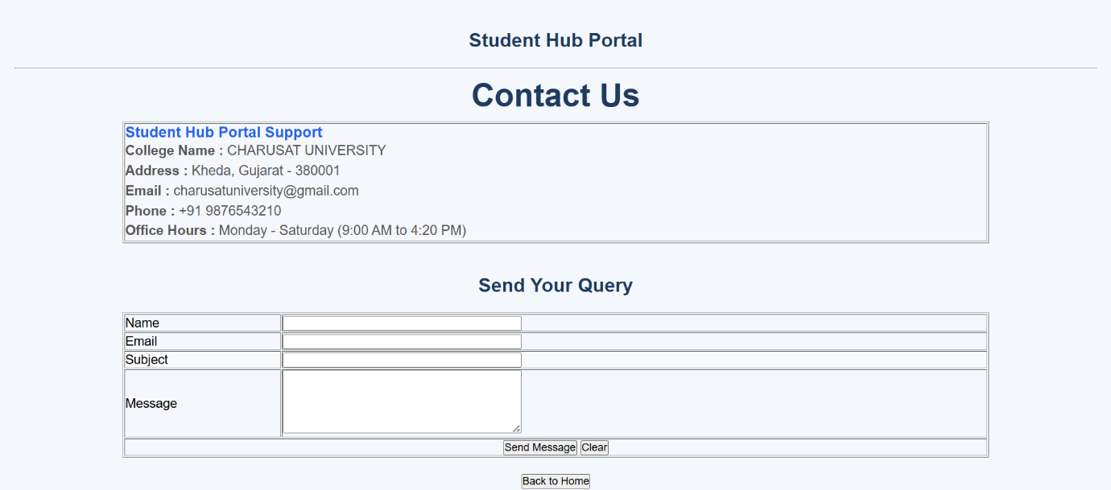
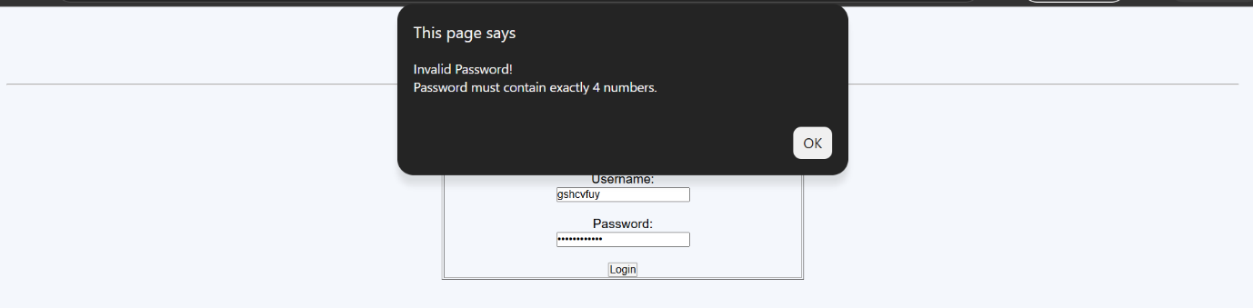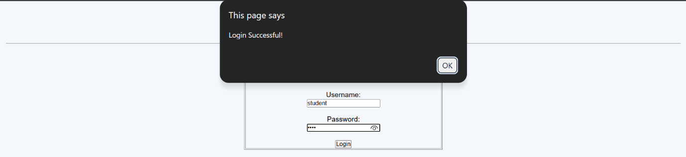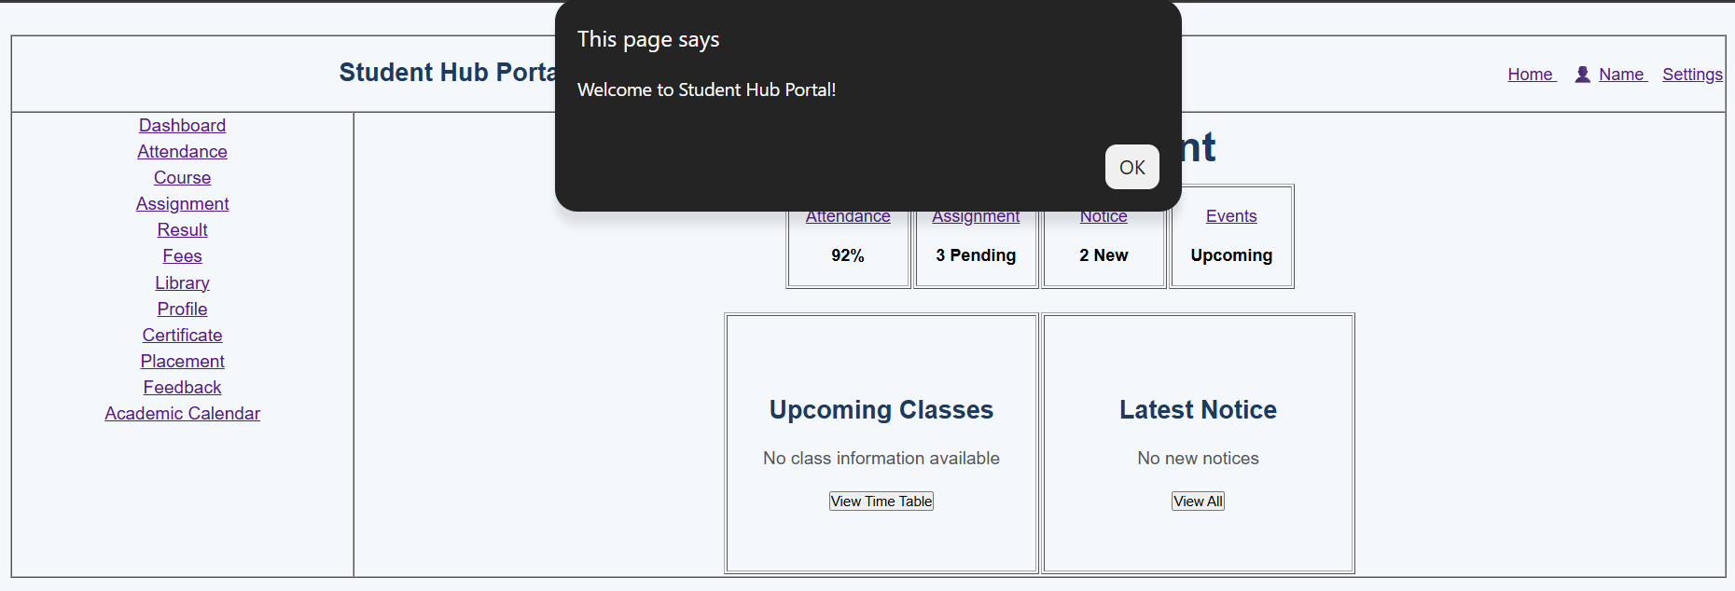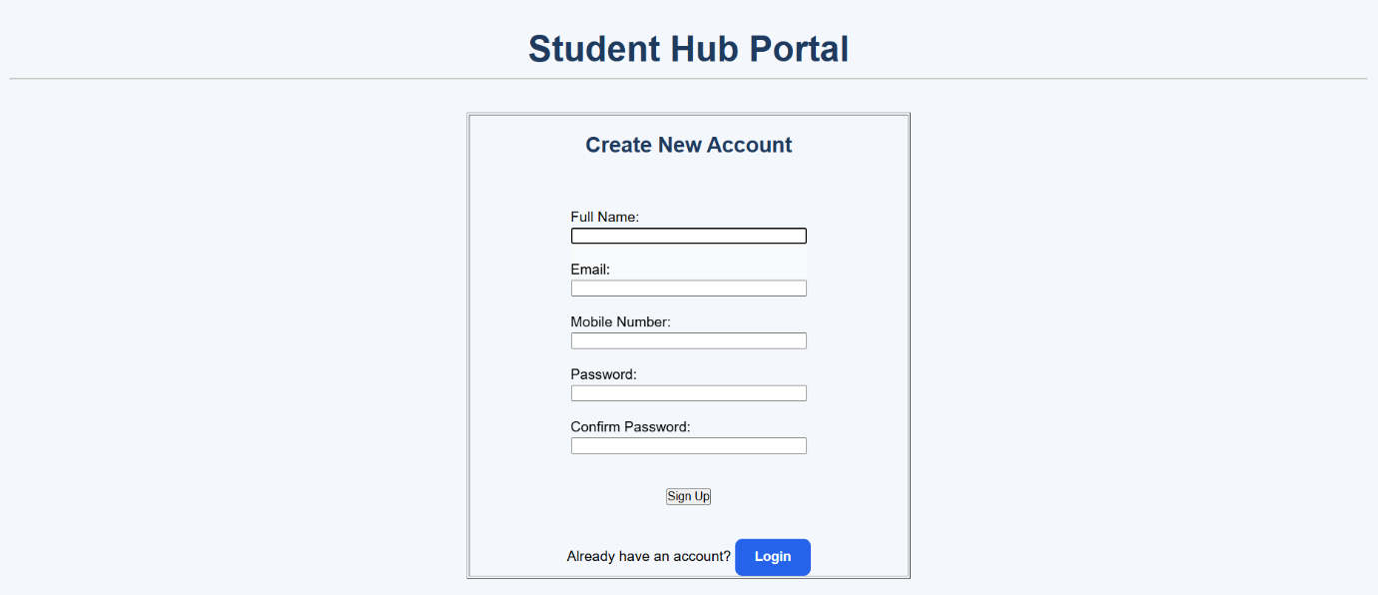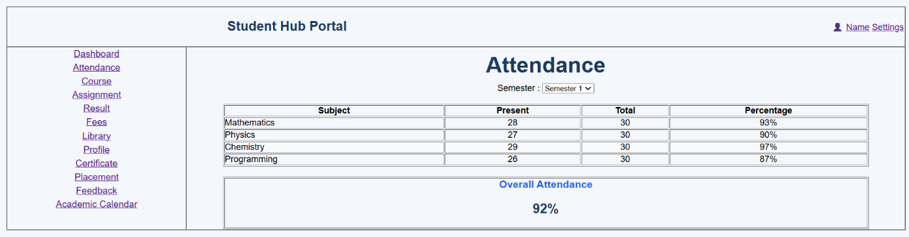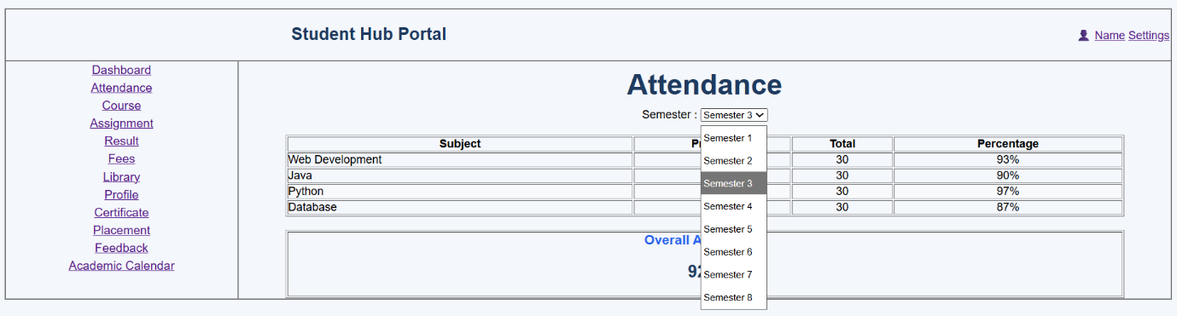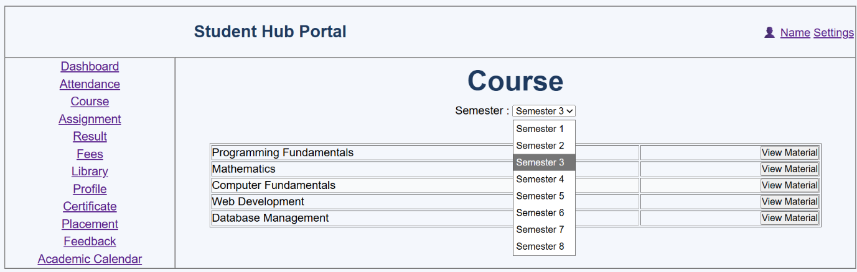
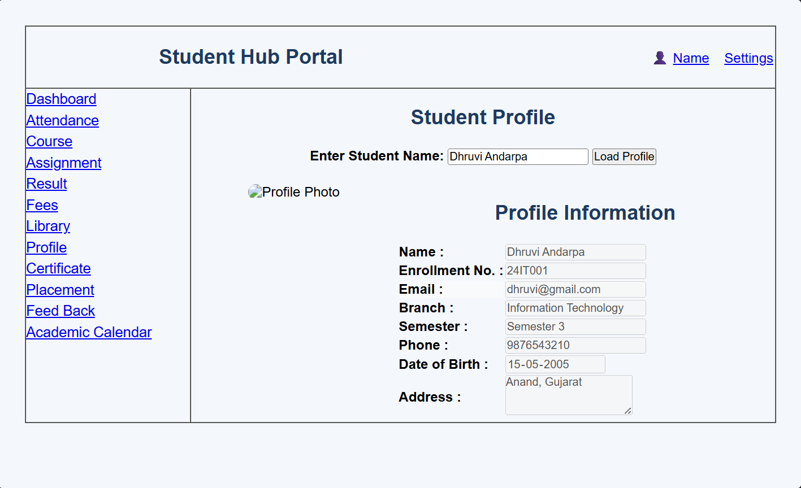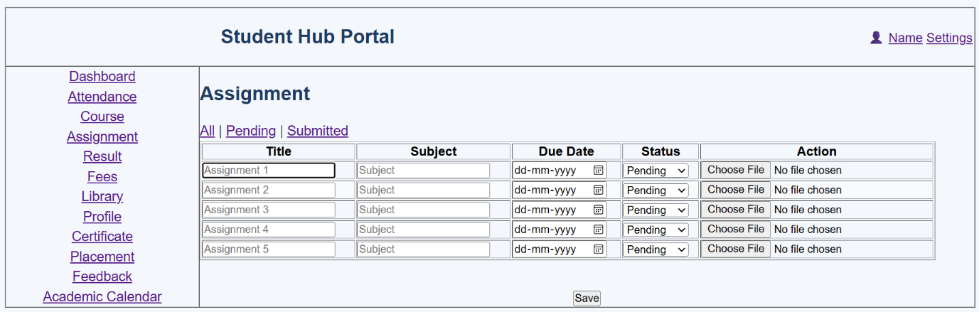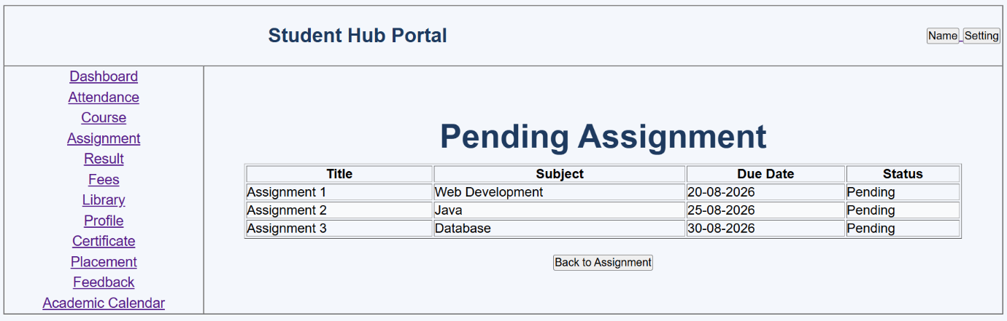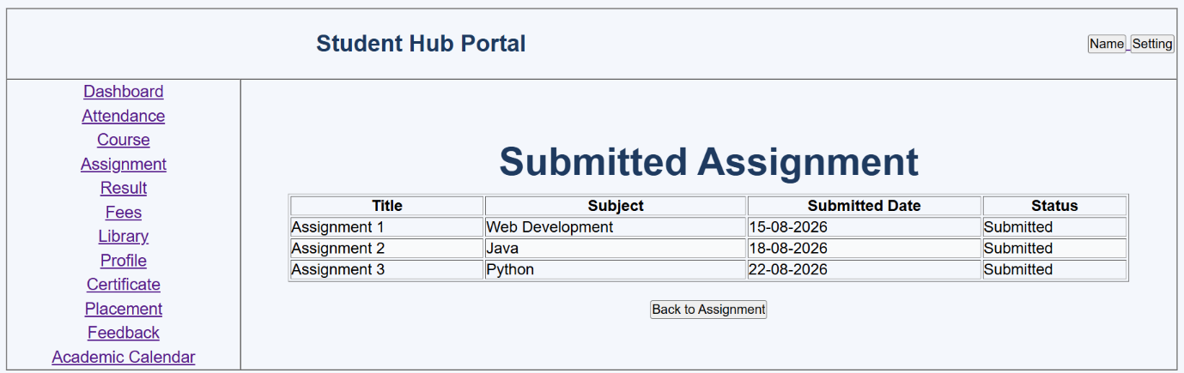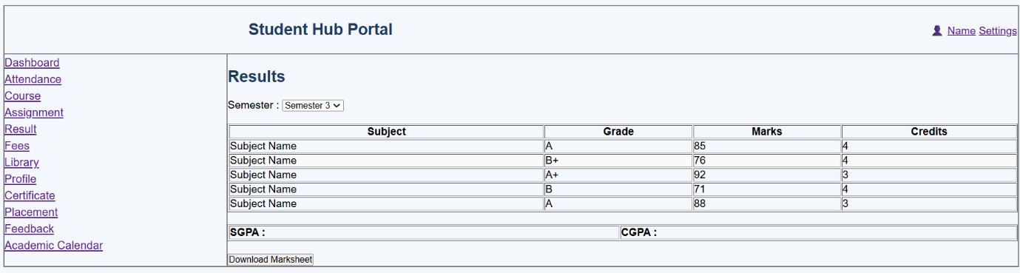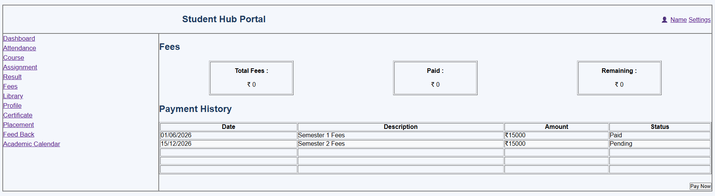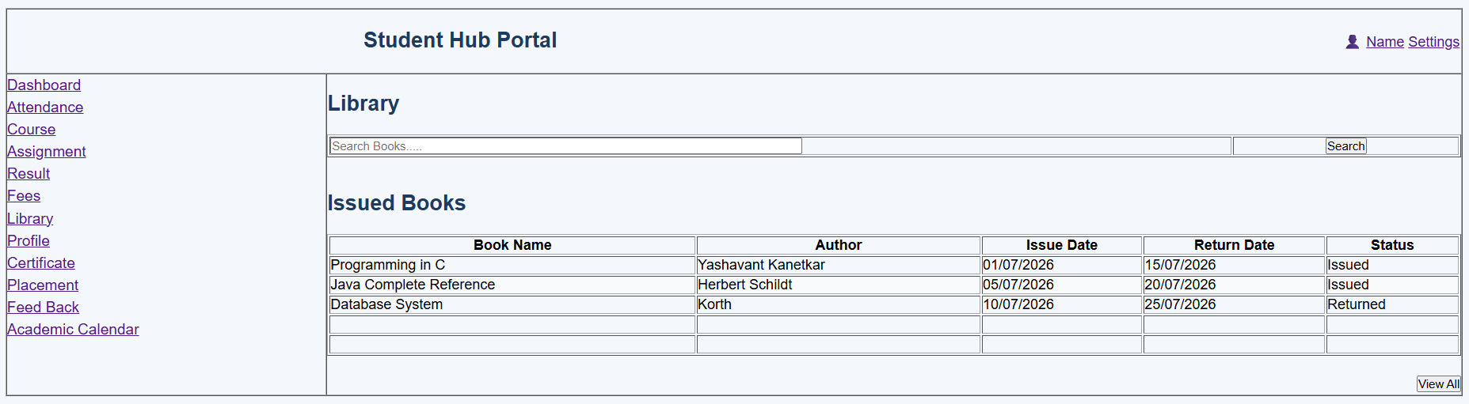
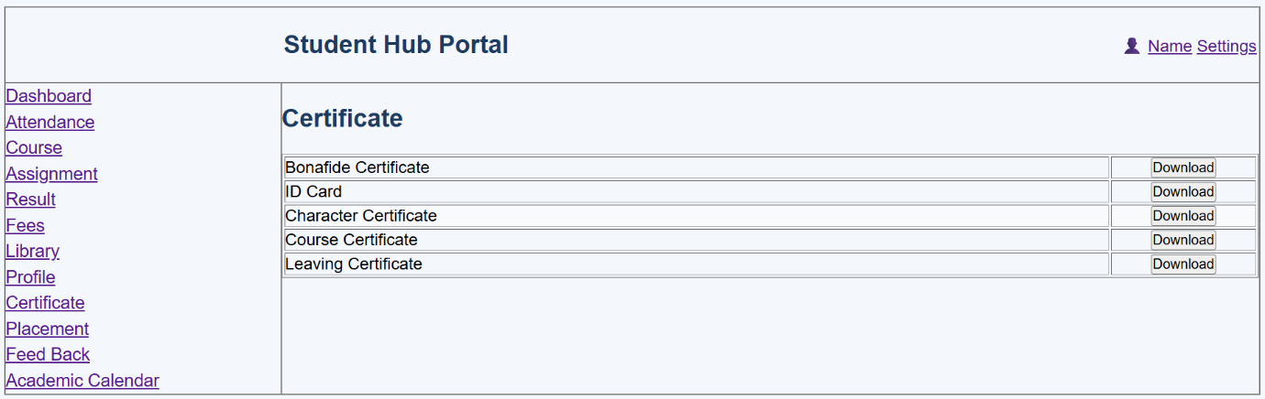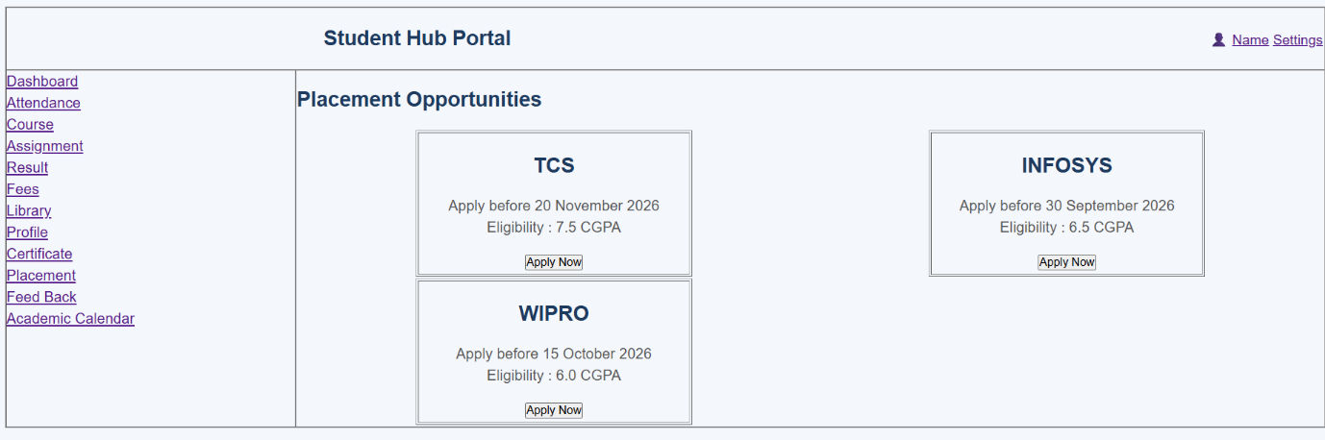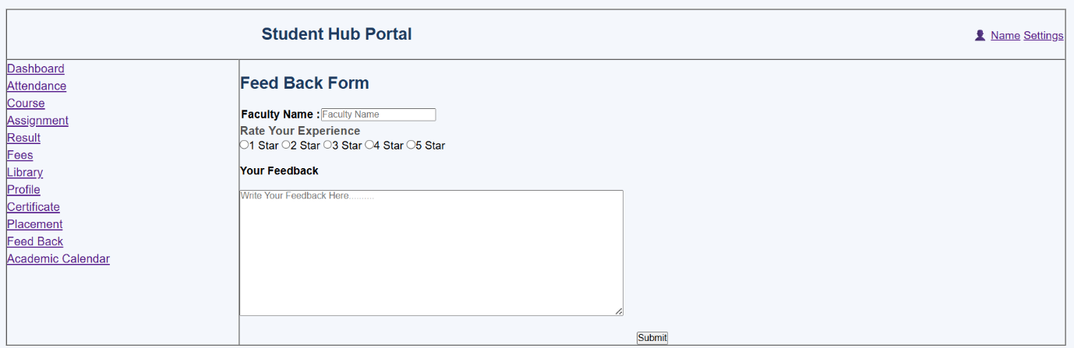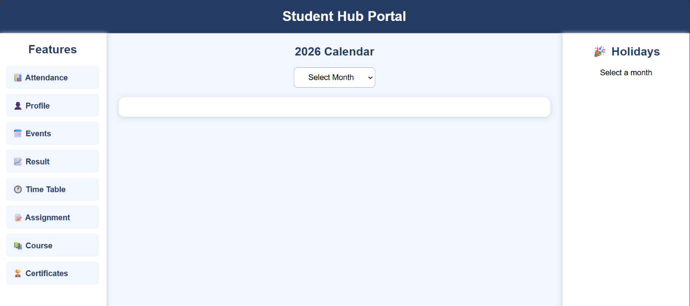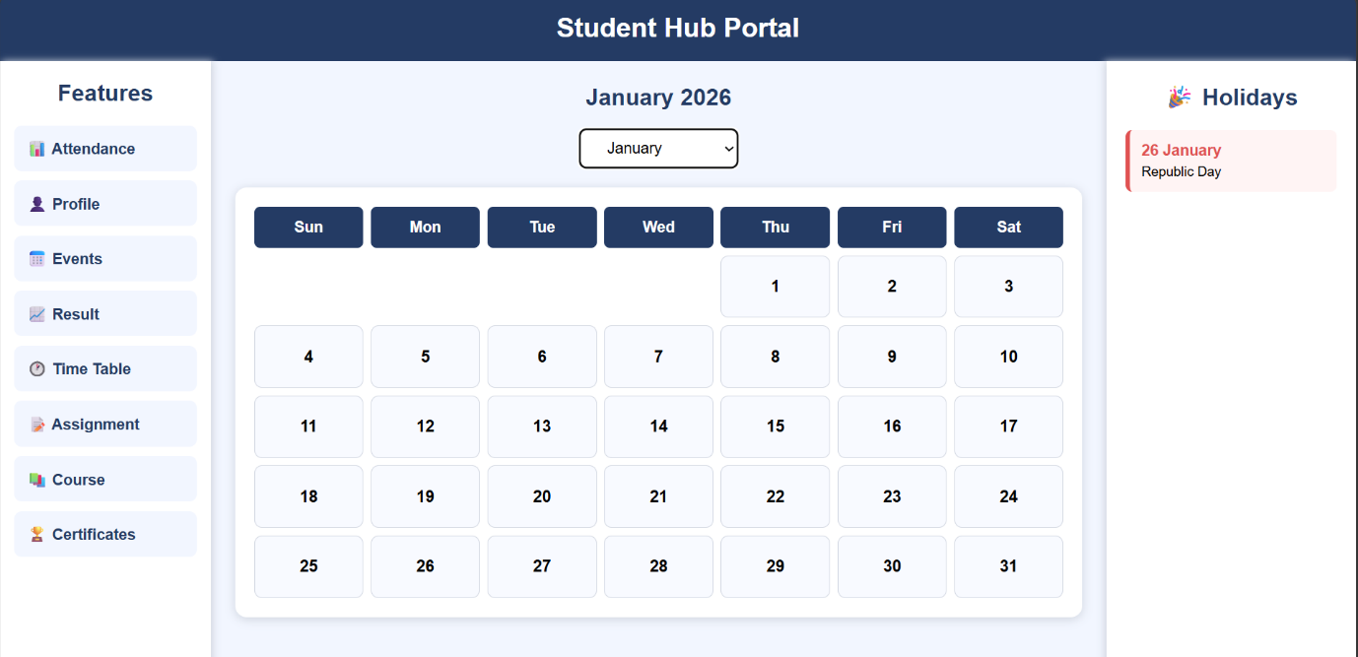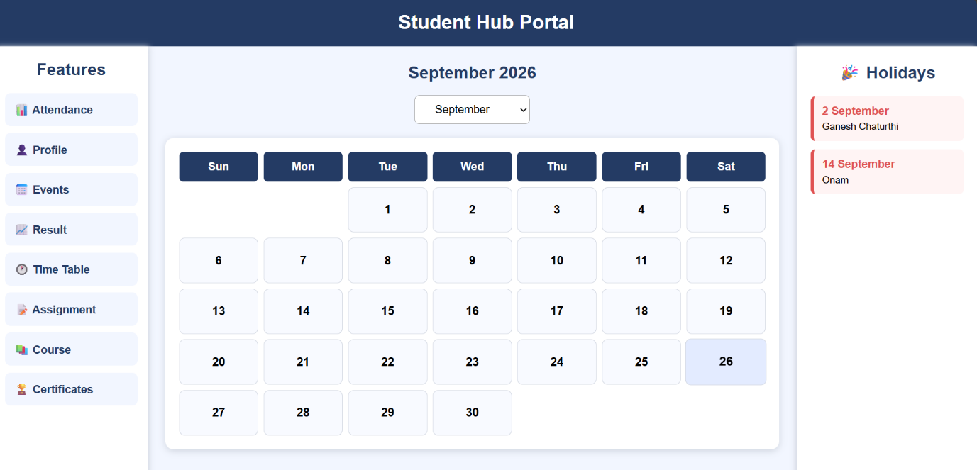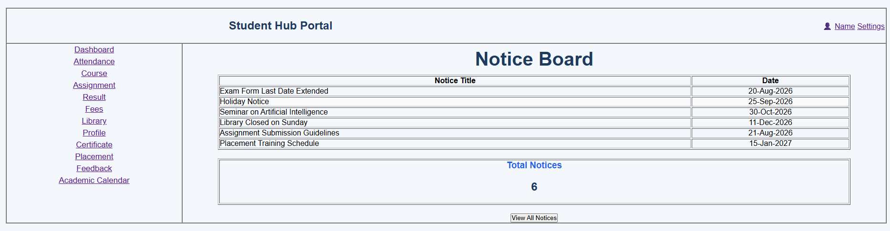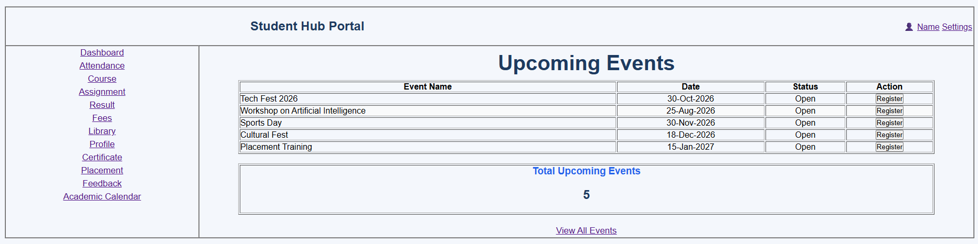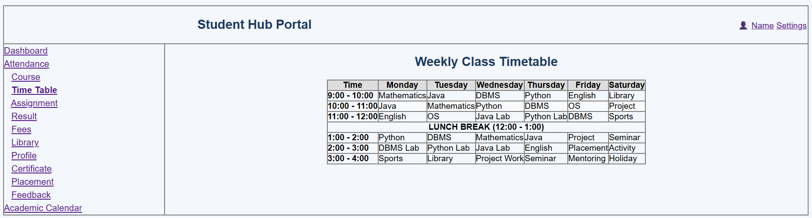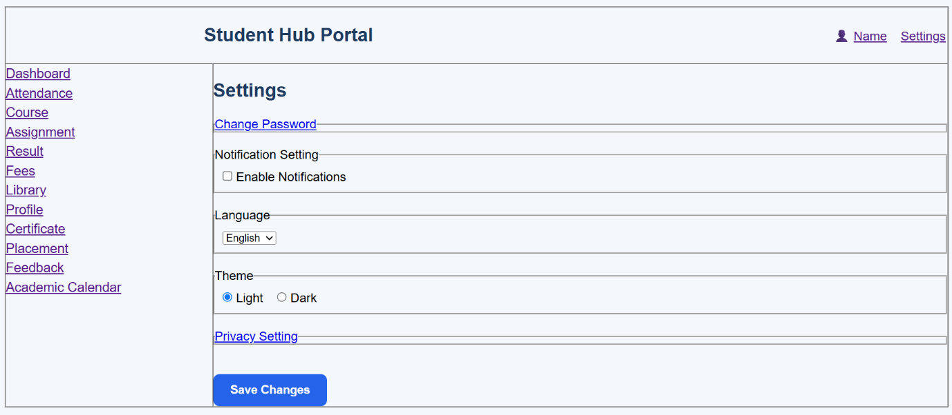

GitHub Repository Link:

https://github.com/Andarpadhruvi1125/Student-Hub-portal.git

C. Challenges Faced: I faced some challenges while fetching JSON data and displaying it correctly on the webpage. I also had difficulty in implementing search, filter, sorting, and pagination and handling loading and error messages.
D. Learning Outcomes: I learned how to fetch and display data from JSON files using Fetch API. I also learned how to use JavaScript array methods like filter(), sort(), and slice() and how to create responsive layouts using CSS Grid and Flexbox.

Faculty Remarks: (Keep this blank for faculty)

